NOTES about moving to and living in JERSEY
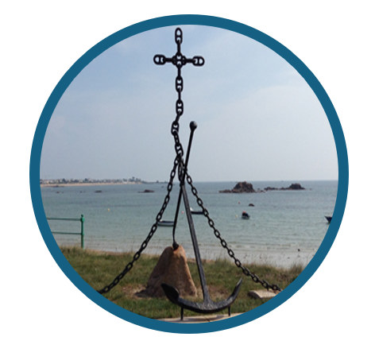 | Thank you for your interest in an appointment in Jersey.  The Circuit Stewards are confident in recommending Jersey as an attractive, outward-looking and friendly place to live and work, with a well-developed sense of community and heritage.  We trust these notes will answer any questions you may have about the uniqueness of Jersey and how living here differs from the United Kingdom. Depending upon your own personal/family circumstances, there may be a need to make further enquiries and/or take advice in order to fully understand the differences.  We will be delighted to assist if you require further information to decide whether a move to Jersey is appropriate for you and your family but, above all, whether it is God’s calling to you at this time.
The Island of Jersey
The Island is self-governing and a Crown Territory. It is approximately 45 square miles and is basically a rectangle of 9 miles by 5 miles. It is 14 miles from the north coast of France, at the nearest point, and about 100 miles south of Portsmouth. Guernsey and Sark are the closest of the other Channel Islands and are 20 or so miles to the northwest. Jersey has many lovely sandy beaches and is home to the world famous Jersey cow and the Jersey Royal new potato.
Jersey has its own government and is autonomous in local matters with its own tax, social security/national insurance and other regulations which differ from the UK. Jersey is made up of 12 Parishes varying in size and population from the capital, St Helier, to the smallest (by population) St Mary.
The Parishes have their own administrations and provide a number of services including local policing (Honorary Police), issuing driving licences, electoral registration etc. The population is 103,267 (2021 Census) and is made up of locals and immigrants, the largest groups of which come from the UK, Ireland, Madeira and Poland.
The Church of England is the established church but the Catholic Church, Methodist Church and other church groups meet regularly in the Island. More information about the Island in general can be obtained from many local web sites including www.gov.je , www.jersey.com and the Parishes websites (links to all 12 websites from www.comite.je).
Jersey Methodist Circuit (part of the Channel Island District).  There are 8 Methodist Churches with a membership of c. 350. Two former Methodist churches continue to operate as a base for community and mission work. See www.jerseymethodist.co.uk  Part-time lay workers are engaged by local churches and the Circuit employs two Church Pastoral staff, a Circuit Administrator and a Circuit Treasurer. | 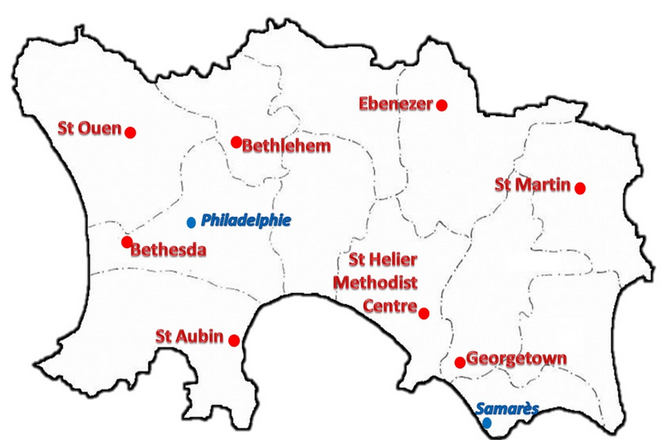
Transport to and from Jersey
There are excellent air and sea links to and from Jersey. Air services are available daily throughout the year to many destinations in the UK and Europe; carriers currently include British Airways, Easyjet, Loganair and Aurigny amongst others. Sea links to the UK and France (fast ferry roll-on/off) are operated by DFDS Ferries.
Services are more frequent in the summer months and prices vary but may be cheaper if booked in advance and outside school holiday periods. Occasionally services are affected by adverse weather conditions, in particular fog can cause flight delays or cancellations and rough seas can affect shipping links.
Accommodation and moving costs
For lay appointments, the availability of accommodation will depend upon the ‘Business Licence’ held by the Circuit (further details will be provided with the outline of the role).
Further details on relocation costs will be provided with the outline of the role.
See also the section on ‘Motoring’ below.
Salary
The salary is paid as set out in the contract of employment. All the main UK banks have branches in the Island and you may wish to open a local account – the banks have to meet strict KYC (Know Your Customer) requirements.
There are many benefits from living on Jersey though it is generally acknowledged that some basic foodstuffs are more expensive than in the UK. There is currently no VAT but there is 5% Goods & Services Tax (GST) which applies to all goods including food.
Social Security/National Insurance
Jersey has its own Social Security; state pensions and benefits differ from those in the UK and you should refer to current information from the UK Department for Works and Pensions (see www.dwp.gov.uk/lifeevent/workage/) and from the Jersey Employment, Social Security and Housing Department (ESSH) (see www.gov.je). This also applies to a working spouse. The different financial year end dates can impact upon pension entitlements unless properly protected. Further details can be obtained both by telephone and from websites.
Family income supplement/allowances also differ in Jersey. There is no Child Tax Credit or Child Benefit, as in the UK, but there is ‘Income Support’ which is a means tested allowance but only available to persons who have been resident for 5 years. Further details are available from ESSH.
Income Tax
The tax year in Jersey is the calendar year. The Income Tax Instalment System (ITIS) rate is calculated from the registration information you provide. ITIS works on the current year basis and you can update the rate if your income changes to make sure you don't underpay. The tax is then finalised the following year when the return is submitted (any unpaid balance would need to be paid or a repayment would be due if the tax was overpaid).
It is important to note that the allowances are based on the period of residence in Jersey in weeks and the tax year is from January-December. It may be that a reduced/nil UK tax bill will be payable in the years of moving from and back to the UK, depending upon your personal circumstances.
Motoring (applies for an appointment of more than 12 months).
If you are bringing a vehicle to Jersey, this will need to be registered with Driver and Vehicle Standards (new number plates will be required - further details available from www.gov.je). There is a potential vehicle importation tax to pay on cars. This is suspended if you have owned the car for at least 6 months and is conditional upon the car being retained for a further 12 months in Jersey.
You will need to exchange UK driving licences for Jersey driving licences; application is made to your Parish (one passport quality photo required; cost is currently £70 for a 10 year licence).
Road tax was abolished in Jersey some years ago in favour of an additional tax on petrol/diesel. However, a ‘windscreen insurance disc’ (WID) is required as proof that the vehicle is insured and this is provided by the insurance company.
Periodic inspections (similar to MOT) are being phased in for all vehicles.
Employment
The position will have a specific ‘employment status’ under the Circuit’s Control of Housing and Work ‘business licence’.
There will be job opportunities for a partner/spouse wishing to seek paid employment that are not restricted to a 5-year residential qualification requirement; but the Circuit may be able to vary its business licence to enable access to a wider range of jobs.
Medical treatment and costs
Medical cover differs from that available in the UK. The Health Insurance Scheme requires 6 months’ residence to qualify for benefit, so for the first 6 months, the Circuit meets all doctor’s and related costs (an introduction to a Doctor/General Practitioner can be made on your arrival). After 6 months, the Health Insurance Scheme provides a subsidy towards doctor’s charges and prescribed drugs on an approved list. Specialist treatment/surgery is available through the local hospital, on referral by a General Practitioner. Hospital treatment is free. Patients may be referred to the UK for tertiary treatment.
Dentists’ and Opticians’ services are not free in Jersey and the Circuit does not fund these costs. Some cover may be available through the hospital e.g. for younger children, and there is a Government contributory dental scheme (conditions apply – please refer to gov.je). It is strongly recommended that all treatment is up to date before leaving the UK mainland.
Expenses
Details are as set out in the employment terms/contract but please note:
Telephone: there are a limited number of local service providers.
Postage: Jersey issues its own postage stamps.
Stationery: The Circuit has an account with Paperclix Ltd, a local stationer, through which items of stationery may be purchased for Circuit business.
Mileage/Travel Expenses: Connexional allowances are paid; the car mileage allowance is 45p per mile (20p per mile for bicycle) and is claimed each quarter. It is a requirement to maintain a log. Mileage is considered fully expended for tax purposes. The Jersey Taxable allowance for mileage is 60p per mile so the 15p extra can be offset against the state tax return.
Travel costs for courses and meetings are normally dealt with on an ‘as and when’ basis, following approval by the Superintendent.
Pets
There are a few restrictions on the import of pets so it is worth checking with your vet and/or Customs and Excise. Information on importing pets and other small animals is also available on www.gov.je.
Local legislation requires all dogs to be licensed and an annual permit must be purchased from the Parish Hall (cost £10 per dog) – see your Parish website (under ‘Licences & Permits’).
Education
Jersey has good public funded and private schools, which take young people through to university stage (see www.gov.je).
Within the States (public funded) system, primary schools cover Reception to year 6, with secondary education for years 7 – 11 provided at a further four schools. Some primary schools have nursery provision and there are also private nurseries. There is an optional 14+ transfer to Hautlieu School for GCSE and ‘A’ level courses. Students may also transfer at 16+ for ‘A’ levels.
For information about the local College for Further Education, which has links to UK universities, see www.highlands.ac.uk). The Government of Jersey gives financial help to Jersey resident students studying in higher education, postgraduate professional qualifications, a 1 year level 3 vocational arts course or Skills Bursary. For details, including residence requirements (‘Who can receive student finance’), see
https://www.gov.je/Working/Careers/16To19YearOlds/EnteringHigherEducation/pages/studentfinancehighereducationfunding.aspx.

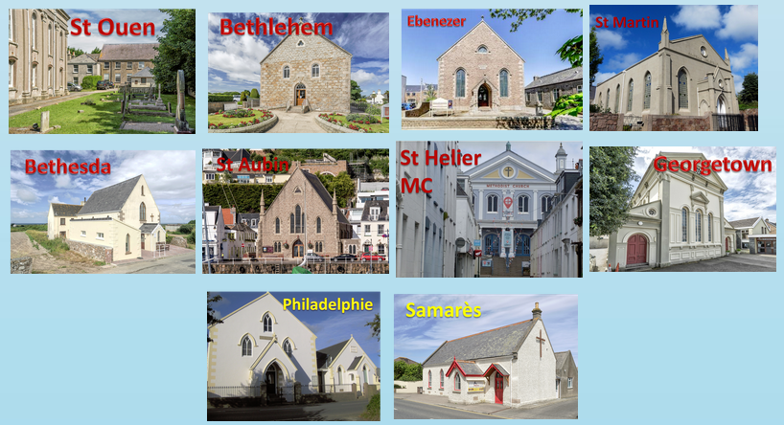
We have made every effort to ensure that this information is accurate but it is only intended to draw attention to major differences, it is not a legal document and is in no way exhaustive (we apologise for any errors or omissions).
Should you have any questions please do contact the Circuit Stewards,
the Circuit Treasurer E: circuit.treasurer.jsy@gmail.com or
the Circuit Administrator E: circuit.office.jsy@gmail.com
and we will endeavour to find the answer for you!
Thank you for your interest in an appointment in Jersey.

