St Helier Methodist Centre

May 10th, 2020

All Ages, All Nations, All stages of Faith
WELCOME
LIBERATION DAY SERVICE ON LINE 9.30am Saturday May 9th

To follow the service just click on one of the links below.

link to Facebook - https://www.facebook.com/StHelierMethodist
link to Instagram - https://www.instagram.com/stheliermethodist
link to YouTube https://www.youtube.com/channel/UCDQaDzq2_WXPj31MhF5SCgA

Notices

In addition to the usual online Sunday service there is a Liberation Day Service this Saturday at 9.30am led by Tony. To access use one of the links on the front page using your ctr button and click the mouse.
----
Please continue to remember all front-line workers and particularly for those who are members of our church praying that they may know safety, strength and peace. They have our grateful thanks.
----
Messrs. De Lay Haye and Morling are pleased to announce that their potatoes will soon be ready for consumption. If patrons would like to email the aforementioned personages they will endeavor to maintain supply even during these peculiar times. In lieu of payment, debts, remittance or settlement the management call upon your unwavering generosity to confer donations towards the work of Christian Aid which last year exceeded £1,000 guineas.

Cheques payable to Christian Aid may be sent c/o St Helier Methodist Centre, Halkett Place, St Helier JE2 4WH or offered at your convenience on delivery.

Messrs. De Lay Haye and Morling remain your most humble and ingratiating and obsequious servants.
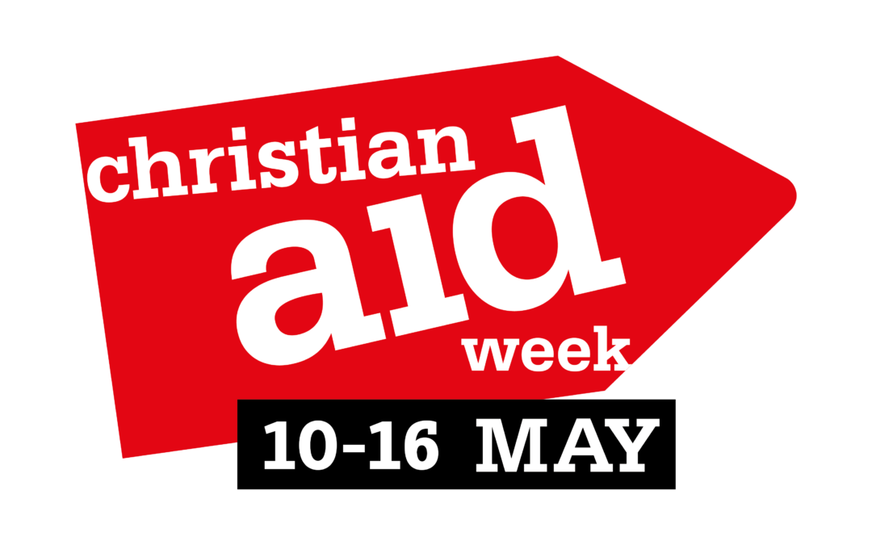

Kairos News
40km for Freedom
From May 4th -11th Cathy, Lou and colleagues at Kairos Arts are running or walking 5km per day for 8 days to raise funds for 4 of Kairos Arts' partners that are in critical need at this time of lockdown. Cases of Domestic Abuse have rocketed, so Jersey Women's Refuge is needing to open a second safe house, then the Freedom Businesses we buy products from (in India Sari Bari and Freeset, and SutiSana in Bolivia) need immediate help to pay the wage of their artisans who are at risk of re-exploitation because they cannot work. More information on facebook : kairosartsjersey
Donate by clicking here

Saturday May 16th would've been the Kairos Arts annual fundraiser, so we are planning to put together a
40 minute Festival of Creativity online on facebook (and Youtube hopefully) of local artists, musicians and actors. It will be available to watch from 7.30pm on the 16th. Come and celebrate creativity with us despite the lockdown!

Finally we have 1500 postcards that were to advertise the fundraiser, so we are upcycling them for the Festival by anyone who would like to take one (or a few!) and transform them on their blank reverse with words of hope, a collage or a drawing (all ages and stages of creativity welcome!).
If you would like to decorate one or know others who might like to take part call Cathy to arrange delivery - 07829 710201.
Finished postcards to be back with Cathy by the 14th ready to be assembled into a large collage to be revealed during the Festival!

‘Sarah’s alternative notice sheet pages’

Mystery photo

Where or what is this in the Centre?

Rebus Puzzles

1) print 2) Herring 3) Sta4nce 4) MoOnceon

5) Tickled 6) ccccccc 7) Symphon 8) ThouDeepght

9) Finger Finger Finger 10) M1y L1i1f1e

Quiz

11) Which star was accused of “erotic vagrancy” by the Vatican in 1962?
12) What country’s single name contains all five vowels?
13) Built in Harlow, The Lawn was the first of what in Britain?
14) In 1871, who made their last stand in Père Lachaise cemetery?
15) On old cars, what were trafficators?
16 )Why is the common basilisk nicknamed the Jesus lizard?
17) What line roughly follows the 180° line of longitude?
18) The rod of Asclepius is a symbol of which profession?

Reasons not to give up the day job

Why did the egg get thrown out of class? Because he kept telling yolks!

Why can’t your head be 12 inches long? Because then it would be a foot!

Why did the banana go to the hospital? He was peeling really bad.
And a couple of absolutely up to date jokes
In Germany they prepared for the crisis by stocking up with sausage and cheese. That’s the Wurst Käse scenario.
What’s the difference between COVID-19 and Romeo and Juliet? One’s the coronavirus and the other is a Verona crisis.
Please keep sending them in and anything at all it would be good to share.
How about a caption for this cheery photo?
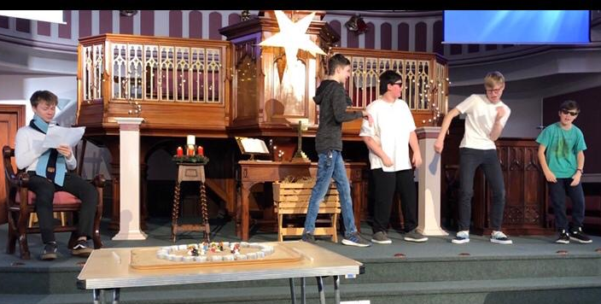

Last week’s mystery photo

= 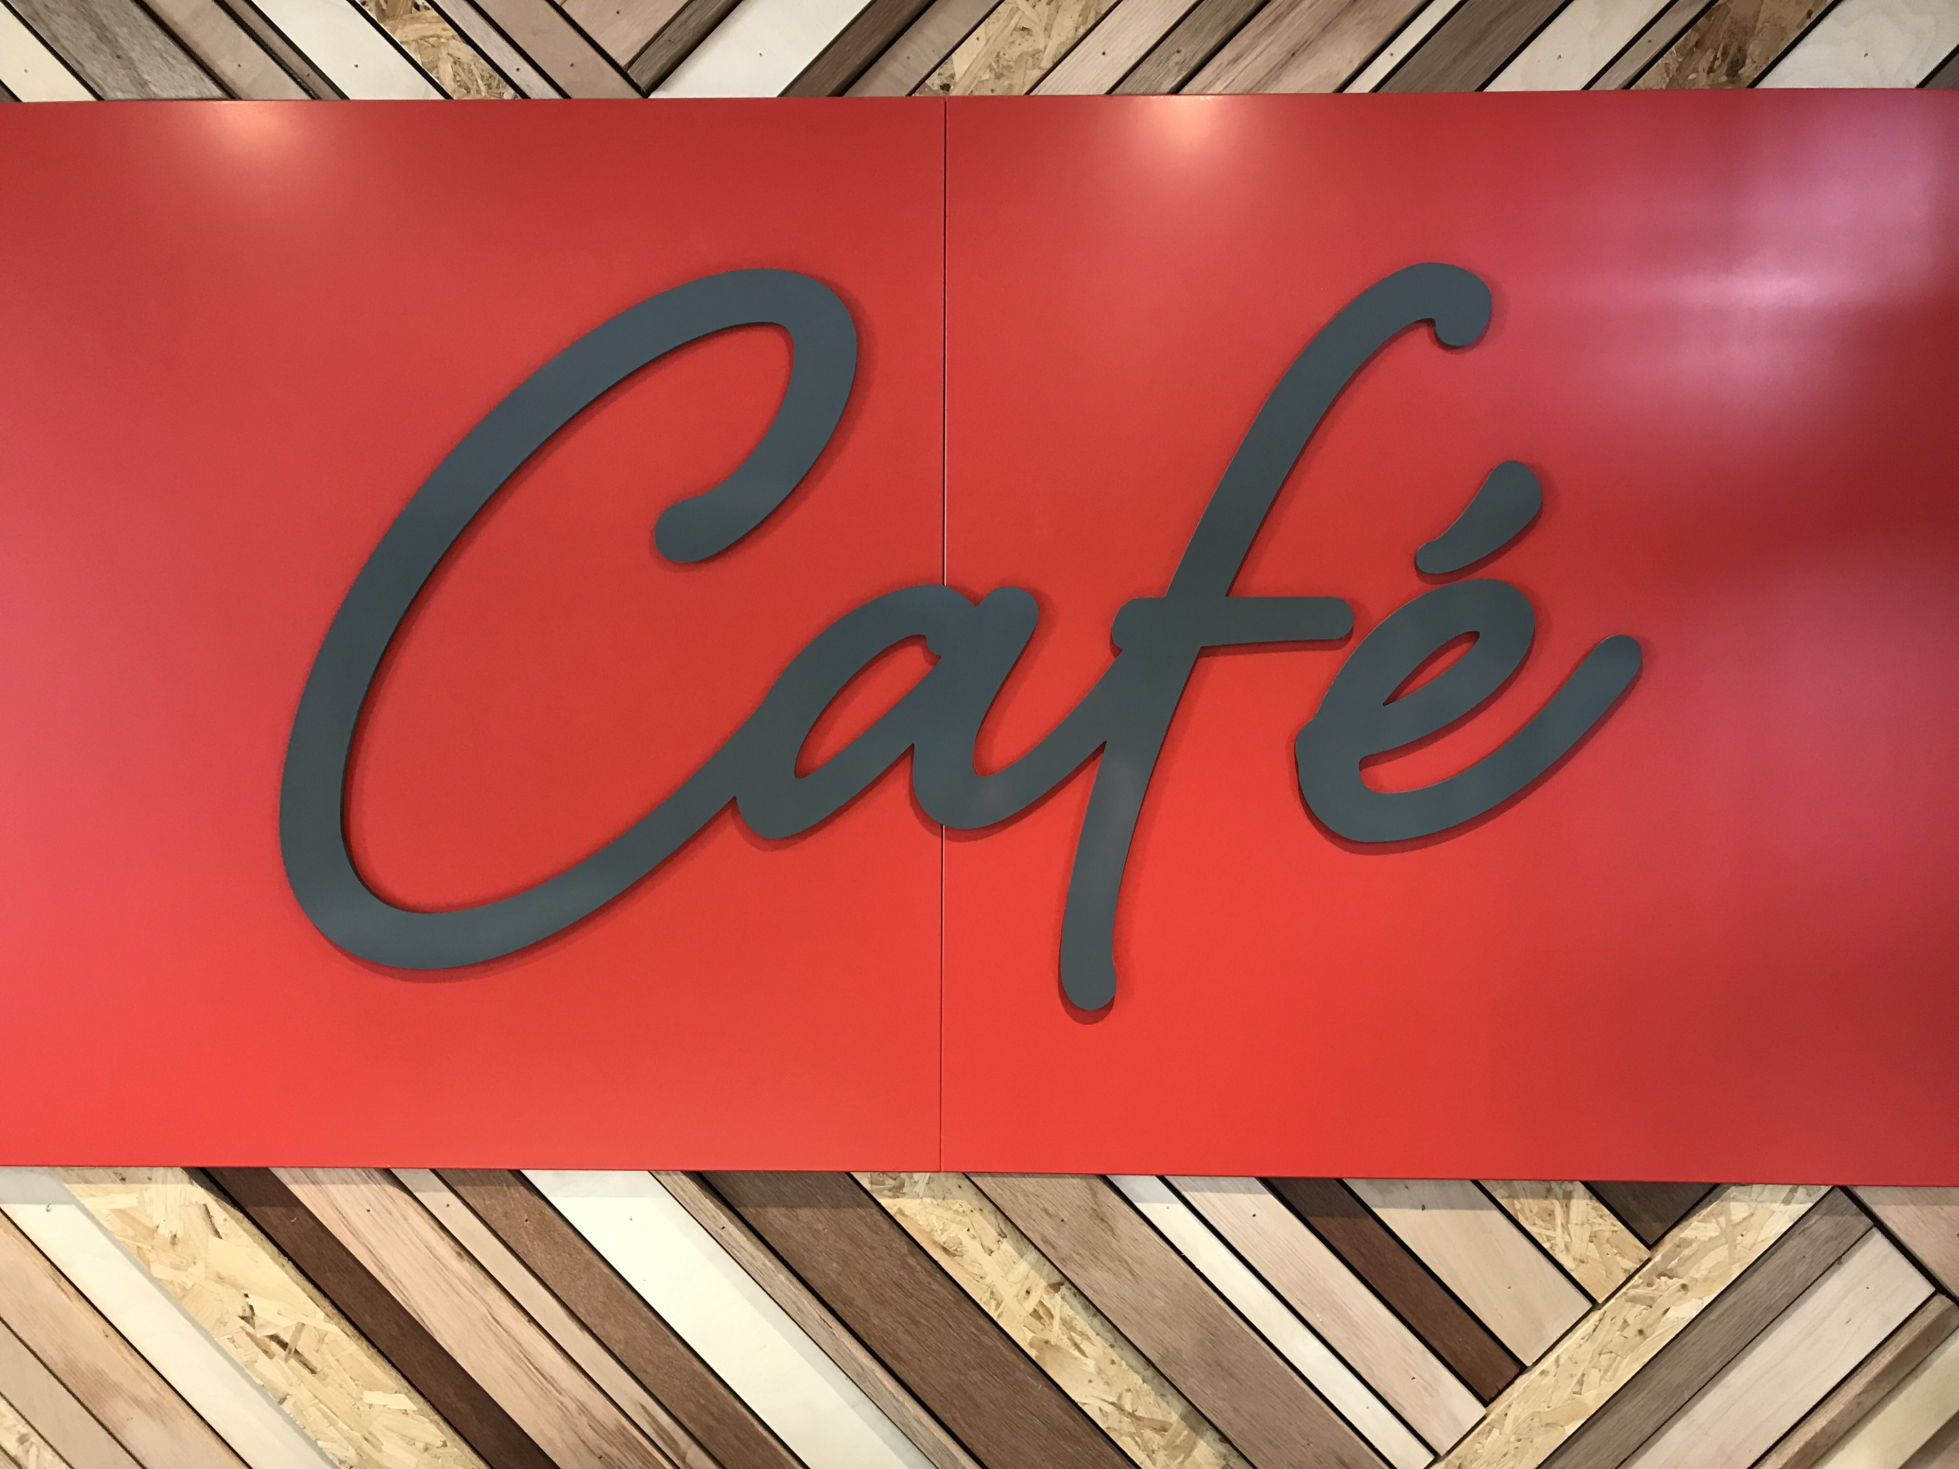

Puzzle answers
1) small print 2) Red herring 3) For instance
4) Once in a blue moon 5) Tickled pink 6) middle C
7) Unfinished Symphony 8) Deep in thought
9) Green fingers 10) For once in my life
11) Elizabeth Taylor 12) Mozambique.
13) Residential tower blocks 14) Paris Communards.
15) Signal arms (replaced by indicators).
16) It can “walk” on water. 17) International Date Line.
18) Medicine.
This week please pray for all involved in the hospitality industry, the residents and staff at Stuart Court and Maison La Corderie and the Rev Jenny Pathmarajah.
Live-streamed services
Wesley’s Chapel in London will continue to live-stream worship, adapted for no physical congregation.
Service times
Wednesday 12:45
Thursday 12:45
Sunday 9:45 and 11:00.
All these services will be available at: www.youtube.com/channel/UCUAUqhmhevz5sqhh72LIMxA

Swan Bank Methodist Church in Burslem will also live-stream worship
Service Time
Sunday 10:30
The service will be available at www.youtube.com/user/SwanBank and www.facebook.com/swanbank/
www.methodistcentre.je
www.jerseymethodist.org.je

Minister: Rev Tony Morling 739906 tony@methodistcentre.je
Pastoral Worker: Mrs Pat Tourtel 747353 pat.tourtel@gmail.com Administrator: Sarah 877517 office@methodistcentre.je

